* Texas Instruments

*Steps to setup BQ79600 and am263x communication*

**TI Selective Disclosure**

|  |  |
| --- | --- |
| **Document Status** | Release |
| **Revision** | **0.1** |
| **Date** | **04/12/2023** |
|  |  |

Table of Contents

A. Setting up the AM263x MCU EVM and dockstation 2

B. Changes required to use SPI as communication interface 2

C. Importing the project into CCS studio 3

## Setting up the [AM263x MCU EVM](https://www.ti.com/tool/TMDSCNCD263?keyMatch=&tisearch=search-everything&usecase=hardware) and [dockstation](https://www.ti.com/tool/TMDSHSECDOCK)

Download and install the SDK, [CCS studio 12.0.0](https://www.ti.com/tool/download/CCSTUDIO/12.0.0), sysconfig, compiler and other documentation from the link [MCU-PLUS-SDK-AM263X Software development kit (SDK) | TI.com](https://www.ti.com/tool/MCU-PLUS-SDK-AM263X)

## 

## Changes required to use SPI as communication interface

1. Refer the [BQ79600 user manual](https://software-dl.ti.com/secure/software/app_bms/bap/BQ79600-Q1_DEVELOPMENT/2%20EVM%20Documentation/sluuc57a.pdf?__gda__=1678396869_b497b8053522bcd6474db929e48f3394) to learn more about the jumper settings and other configuration changes required to use SPI communication.
2. BQ79600 by default comes with jumper settings for UART. If SPI communication will be used to communicate to host **(Current version of sample code only supports SPI )**, place R8 and R10 0-Ω resistors, and remove R7 and R9 resistors on BQ79600EVM.
3. If you want to skip the resistor swapping in the above step, connect pin 69 from ‘TMDSHSECDOC’ to pin ‘7’ ( MOSI ) on J4 of BQ79600, similarly connect pin 67 from ‘TMDSHSECDOC’ to pin ‘8’ ( MISO ) on J4 of BQ79600.
4. Set the J1 and J3 to 12V and apply 12V supply to BQ79600.
5. Apply 34 V power supply to BQ79616 EVM, refer [user guide](https://software-dl.ti.com/secure/software/app_bms/bap/BQ7x61x-Q1_DEVELOPMENT/2_EVM_Documentation/PG2.0_bq79616_bq75614_EVM_User_Guide_SLUUC37_June2020.pdf) for more details.
6. Use 1 pin MTE cable to connect the below pins between BQ79600 EVM and TMDSHSECDOC dockstation.

**Table:** Connections between BQ79600 EVM and AM263x dock station pinout

|  |  |  |
| --- | --- | --- |
| Interface | Pin on BQ79600 EVM | Pin on TMDSHESECDOC |
| MOSI | MISO pin | 67 |
| MISO | MOSI pin | 69 |
| SCLK | SCLK pin | 71 |
| SCS | SCS pin | 73 |
| SPIRDY | SPIRDY pin | 85 |
| 3.3 V | 3.3 V pin | 3.3 V pin |
| GND | GND | GND |

1. Make sure the jumpers on the AM263x control card is matching the settings in the below pic

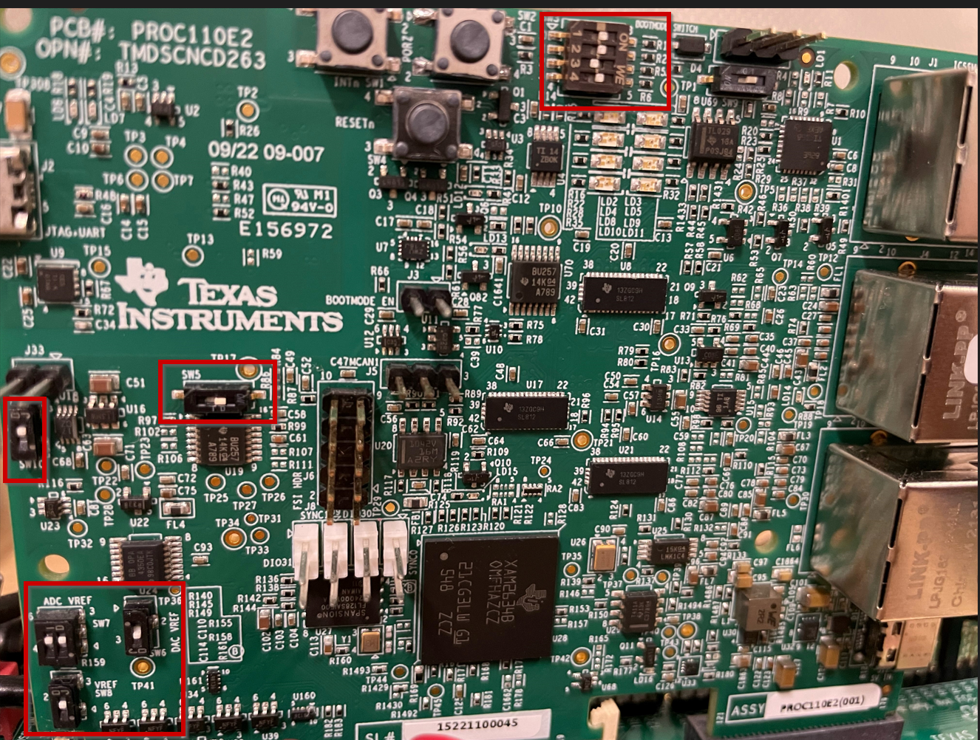

**Jumper settings on AM263x control card**

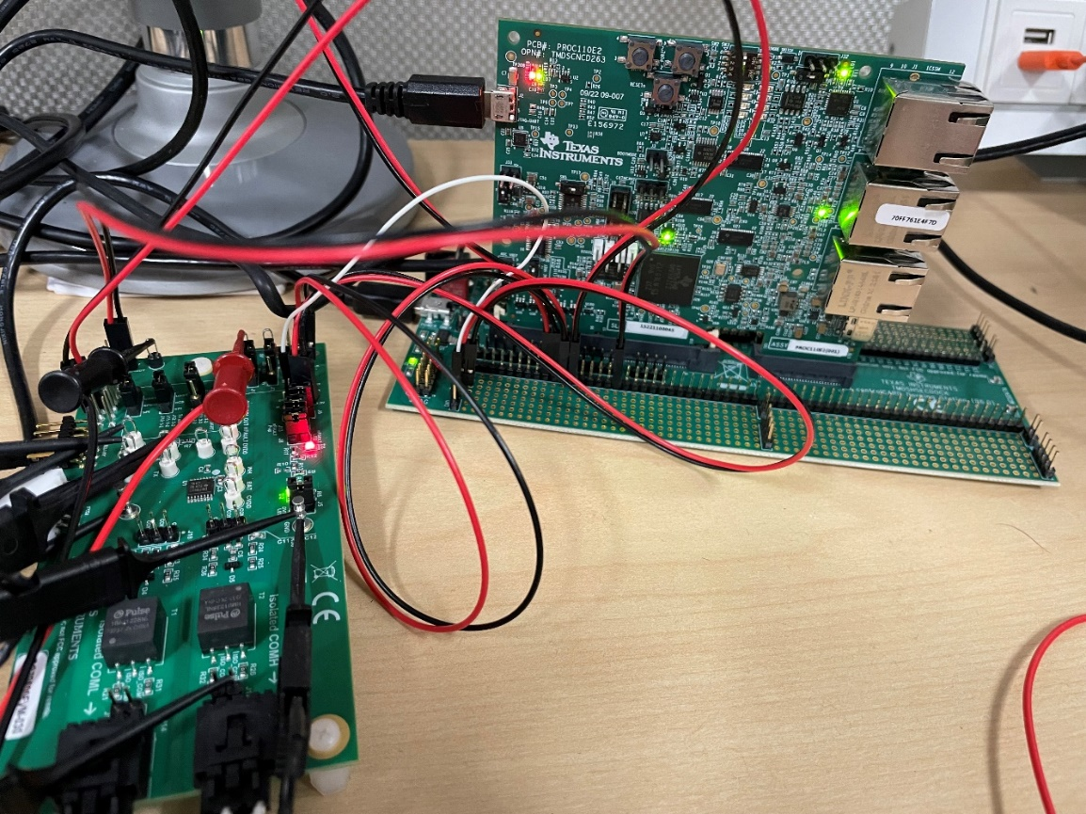

## Importing the project into CCS studio

Once all the tools mentioned in the section ‘A’ is installed and steps in section ‘B’ is complete. Open the CCS studio, import the downloaded project for bq79616 as shown below

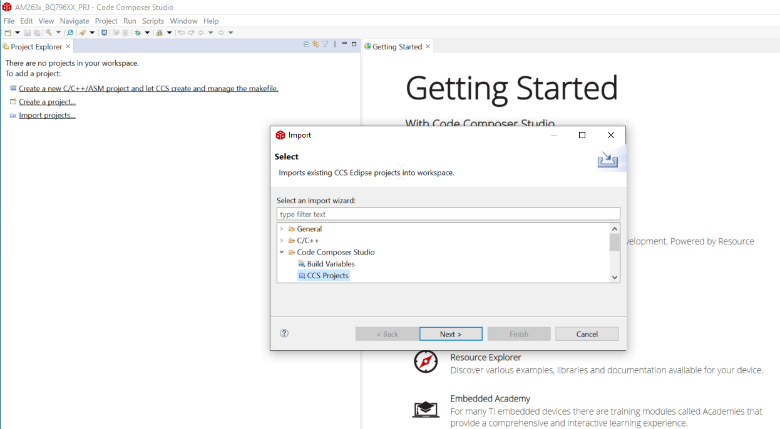

**Import the CCS project**

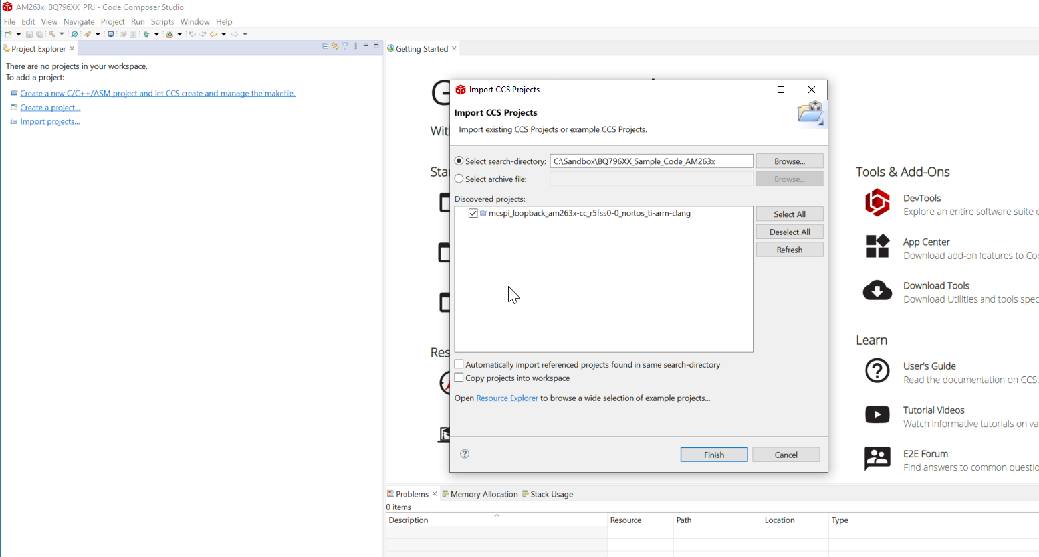

**Select the imported project**

Once the project is imported, right click and select ‘Property’, in the ‘Products’ tab make sure the SDK and SysConfig versions are matching what you have installed, else select each of them and ‘Edit’ to select the proper version of SDK and SysConfig.

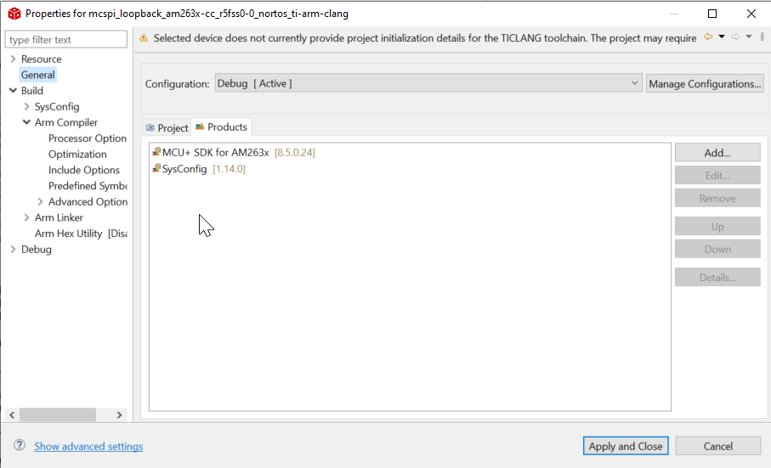

**Properties -> General**

If you want to update the listed items to newer version, press ‘Add’ button. Then in the ‘Select a Product’ popup click on the ‘Preferences’.

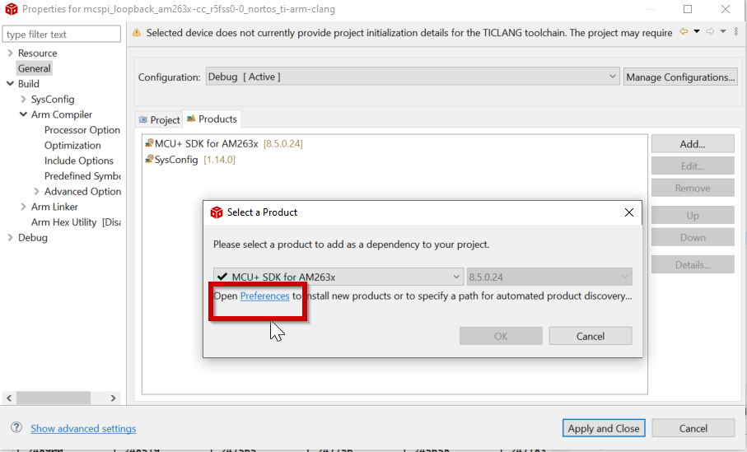

**Properties->General -> Products tab -> Add -> Preferences**

In the ‘Preferences’ window you can see all the software tool versions that are available, you can add new version by clicking ‘Add’.

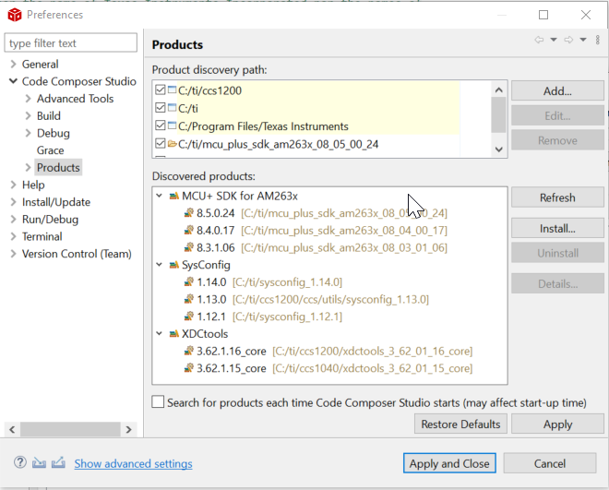

**Preferences**

To update the number of stack devices used, please update the value in bq796xx.h as shown below. ‘TOTALBOARDS’ indicates the count including the bridge device BQ79600.

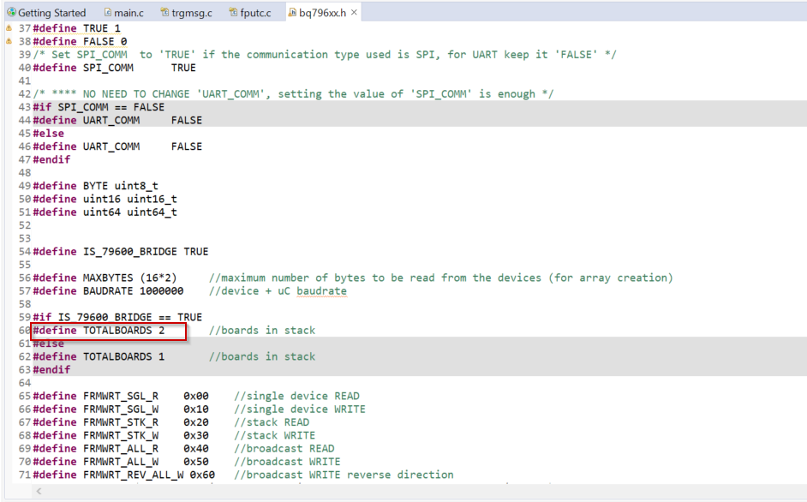

**bq796XX.h**

Once the project is imported, click on ‘Debug’ ( F11 ) to compile and run the code.

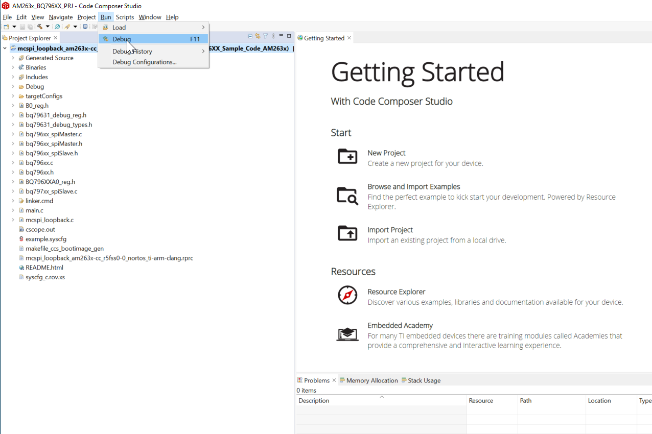

When you run ( F8 ), you should see the cell voltages printed on the console as below.

